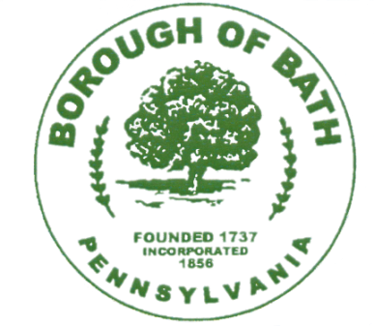
Borough of Bath
121 S. Walnut Street, Bath, PA 18014
Phone: 610-837-6525 Fax: 610-837-8989

ALCOHOL PERMIT
BOROUGH OF BATH - NORTHAMPTON COUNTY, PA

LICENSE NO. 2022 Farmers Market

This license is issued to: ________________________________________________________

Name of Vendor:_______________________________________________________________

Address: ___________________________________________

Contact Person: _____________________________________ Phone#: _________________

For the sale of: ________________________________________________________________
(Only tap beer and cans shall be permitted in park areas or designated spaces. NO glass containers)

For a period of ______________(______) days within the Borough of Bath commencing

_______________________ (M/Day/Yr) and ending ______________________ (M/Day/Yr).

Liquor Control Board License#___________________________________________________

******************************************************************************

________________________________________ ______________________________
Authorized Signature Date of Issuance

DISPLAY IN A CONSPICUOUS LOCATION
AND/OR EXHIBIT UPON REQUEST

